1. Introduction to Boltzmann Machine
👉 What is a Boltzmann Machine?
A Boltzmann Machine is a:
- Stochastic (probabilistic) neural network
- Energy-based model
- Used for learning probability distributions

1️⃣ Stochastic (Probabilistic) Neural Network
A stochastic neural network means that neuron activations are not fixed — instead of always giving the same output for the same input, neurons activate based on probabilities. Unlike traditional neural networks where neurons deterministically produce outputs using activation functions, stochastic networks introduce randomness to model uncertainty and variability in data. This probabilistic behavior allows the network to explore different possible representations of the same input, which is useful in generative modeling and unsupervised learning.
🔹 Key Points
- Neurons activate with probability instead of certainty.
- Same input may produce slightly different outputs.
- Helps model noisy and uncertain real-world data.
- Useful for discovering hidden patterns.
- Supports generative learning tasks.
🔹 Example
Imagine a movie recommendation system:
- A user watches action movies often.
- Hidden neuron probability = 0.7 for “likes thriller”.
- Sometimes neuron activates, sometimes not.
- Model learns uncertainty in user preferences instead of fixed decisions.
Another simple example:
- Input image of digit “5”.
- Hidden neuron detecting curves activates with 80% probability.
- Network explores multiple feature interpretations.

⚡ 2️⃣ Energy-Based Model
An energy-based model assigns an energy value to every possible configuration of visible and hidden units. The main idea is that realistic data patterns should have low energy, while unrealistic or random patterns should have high energy. During training, the model learns to reduce energy for real examples and increase energy for unlikely ones. Instead of directly predicting labels, the network evaluates how “natural” or “likely” a data configuration is.
🔹 Key Points
- Each data pattern gets an energy score.
- Low energy → realistic pattern.
- High energy → unlikely or random pattern.
- Training adjusts weights to shape an energy landscape.
- Helps model data structure rather than direct predictions.
🔹 Example
Consider handwritten digit images:
- Real digit images → low energy states.
- Random noisy pixels → high energy states.
- Model learns which pixel combinations look like real digits.
Another example:
- Music recommendation data.
- Common listening patterns get low energy.
- Rare or unrealistic song combinations get high energy.

🎯 3️⃣ Learning Probability Distributions
Learning probability distributions means understanding how data is generated rather than predicting a specific label. Instead of learning input-output mapping, the model learns the statistical relationships between features and how often certain patterns occur. This allows the model to generate new samples, reconstruct missing information, or identify unusual data points.
🔹 Key Points
- Learns overall data patterns and structure.
- Models likelihood of feature combinations.
- Enables data generation and reconstruction.
- Works without labeled data.
- Useful for representation learning.
🔹 Example
Movie ratings dataset:
- Users who like sci-fi often like action.
- Model learns probability relationships between genres.
- Can recommend new movies based on learned patterns.
Image dataset example:
- Learns probability of edges, textures, and shapes.
- Can reconstruct partially missing images.
- Can generate new images similar to training data.

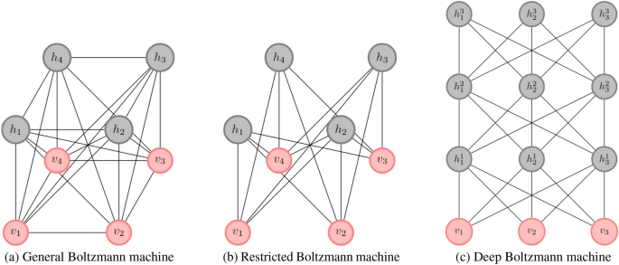
Goal:
👉 Learn patterns in data without labels.
It tries to:
Model probability of data distribution

🔹 Key Idea
Instead of predicting outputs like a normal neural network:
RBM tries to:
Learn how data is generated
Example:
- Learn structure of handwritten digits
- Learn user preference patterns
- Learn feature representation

🔷 2. Restricted Boltzmann Machine (RBM)
✅ Definition
A Restricted Boltzmann Machine is a:
👉 Two-layer stochastic neural network used for unsupervised learning.
It consists of:
- Visible Layer (input data)
- Hidden Layer (feature detectors)

📊 RBM Architecture
Visible Layer (Input Units)
v1 v2 v3 v4
│ │ │ │
●────●────●────●
\ | / /
\ | / /
\ | / /
\|/ /
●●●●
Hidden Layer (Feature Units)
h1 h2 h3

🔥 Important Restriction (Why "Restricted"?)
There are NO connections:
❌ between visible units
❌ between hidden units
Only:
Visible ↔ Hidden
This restriction makes training computationally easier.

🔹 Layers Explained
🟢 Visible Layer
- Represents actual input data
- Example:
Pixel values of image
User ratings
Binary features

🔵 Hidden Layer
- Learns patterns/features
- Discovers structure automatically
Example:
- Stroke patterns in digits
- Movie preference clusters

🔷 3. How RBM Works (Conceptual Learning Process)
RBM performs two phases:

Phase 1 — Forward Pass (Encoding)
Visible → Hidden
Input data activates hidden neurons.
Hidden units learn:
Probability of feature presence
Example:
Digit image → detect curves, edges

Phase 2 — Reconstruction (Decoding)
Hidden → Visible
Model tries to reconstruct original input.
Goal:
Minimize difference between original & reconstructed data
This is how RBM learns.

🔷 4. Energy-Based Learning Concept
RBM assigns an energy value to configurations.
Low Energy:
Likely patterns
High Energy:
Unlikely patterns
Training tries to:
Minimize energy for real data
Maximize energy for random noise

🔷 5. Applications of RBM
- Feature learning
- Collaborative filtering
- Recommendation systems
- Dimensionality reduction
- Pretraining deep networks
- Deep Belief Networks (DBN)

🔷 6. Boltzmann Machines vs Neural Networks
Let’s compare deeply.

📊 Architecture Difference
Neural Networks
Input → Hidden → Output
Feedforward
Deterministic
Boltzmann Machines
Bidirectional connections
Probabilistic units
Energy-based

📊 Detailed Comparison Table
Feature | Boltzmann Machine | Neural Network
Learning Type | Unsupervised | Supervised / Unsupervised
Structure | Stochastic Graph | Directed Layers
Connections | Bidirectional | Mostly Forward
Output | Probability Distribution | Prediction
Training Method | Energy Minimization | Gradient Descent
Activation | Probabilistic | Deterministic
Goal | Learn Data Distribution | Predict Target
Computation | Heavy | Efficient
Real-Time Use | Rare | Very Common

🔥 Major Conceptual Difference
Neural Network
Learns:
Input → Output mapping
Example:
Image → Cat/Dog

Boltzmann Machine
Learns:
How data is structured internally
Example:
What patterns exist in images?

🔷 7. RBM vs Traditional Neural Network (Conceptual Diagram)
Neural Network
Input → Hidden → Output
One directional.

RBM
Visible ↔ Hidden
Two directional probability learning.

Types of Boltzmann Machines
Boltzmann Machines can be categorized into different types based on their network structure and connectivity, each designed to balance model expressiveness and computational efficiency for learning complex data distributions.
1. Restricted Boltzmann Machine
A Restricted Boltzmann Machine (RBM) is an energy-based probabilistic neural network used for unsupervised learning, capable of modeling complex data distributions and learning meaningful features from input data.
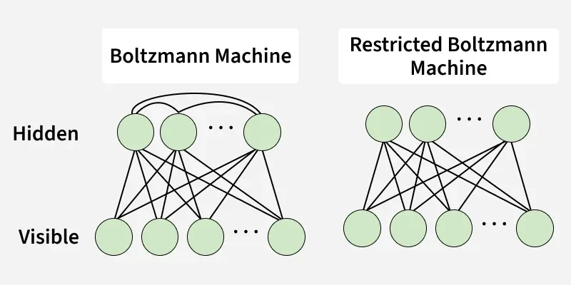
Boltzmann Machine vs Restricted Boltzmann Machine
- RBM consists of two layers: a visible layer for input data and a hidden layer for learning features, with connections only between layers.
- Every visible unit is connected to every hidden unit, forming a bipartite graph.
- RBMs are trained using Contrastive Divergence, which reconstructs input data from hidden representations.
- Weights and biases are updated to minimize reconstruction error, allowing the network to capture underlying patterns.
How Restricted Boltzmann Machine (RBM) Works:
- Initialize random weights and biases between visible and hidden units.
- Feed input to the visible layer; hidden units calculate activation probabilities and sample states.
- Reconstruct the visible layer from hidden states.
- Update weights and biases using Contrastive Divergence to reduce reconstruction error.
- Repeat until the RBM effectively models the data distribution.
Advantages
- RBMs can learn patterns and features from unlabeled data.
- They are useful for feature extraction and dimensionality reduction.
- RBMs can be used to pretrain deep neural networks.
- They model complex data distributions and capture correlations.
Limitations
- Training can be slow and computationally intensive for large datasets.
- Contrastive Divergence is an approximation and may not converge to the true distribution.
- RBMs struggle with very large or high-dimensional data.
- Standard RBMs work best with binary data and need modifications for continuous data.
2. Deep Belief Networks (DBNs)
Deep Belief Networks (DBNs) are multi-layered probabilistic neural networks used in deep learning to automatically discover patterns in large datasets. They are composed of stacked Restricted Boltzmann Machines (RBMs), where each layer learns features from the output of the previous layer, gradually building complex representations of the data.
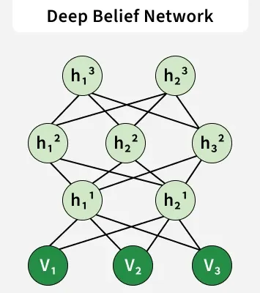
Deep Belief Network
DBNs have a hybrid structure:
- The top two layers form an undirected RBM.
- Layers below have directed connections downwards.
- Each layer consists of stochastic hidden units, often binary, that act as feature detectors.
DBNs can be trained using two main approaches:
- Greedy Layer-wise Training: Each RBM layer is trained independently and once trained, the direction of connections is established between layers.
- Wake-Sleep Algorithm: The network is trained upwards (wake phase) and then downwards (sleep phase), adjusting weights in both directions.
How Deep Belief Networks Work:
- Pre-training: Train each layer as an RBM to learn features and capture input data distribution.
- Fine-tuning: Adjust the network for a specific task using supervised learning (e.g backpropagation).
- Greedy Layer-wise Training: Train RBMs layer by layer with Contrastive Divergence and set directed connections downward.
- Top Layer Sampling: Use Gibbs sampling on the top two layers to extract high-level features.
- Bottom-up and Top-down Passes: Infer latent variables and fine-tune generative weights.
- Iteration: Repeat until the network effectively models the data distribution.
Advantages
- Can automatically learn hierarchical feature representations from data.
- Suitable for high-dimensional inputs like images and speech.
- Pre-training improves learning efficiency and reduces problems like local minima.
- Supports both unsupervised pre-training and supervised fine-tuning making it versatile.
Limitations
- Training is computationally intensive, especially for deep networks.
- Greedy layer-wise pre-training can be slow for many layers.
- Contrastive Divergence is an approximation and may not perfectly capture data distribution.
- Requires careful tuning of hyperparameters like learning rate, number of hidden units, etc.
3. Deep Boltzmann Machines (DBMs)
Deep Boltzmann Machines (DBMs) are generative neural networks that learn complex, hierarchical representations of data. Unlike Deep Belief Networks (DBNs), all connections between layers are undirected, enabling the network to capture more sophisticated features. DBMs consist of multiple hidden layers of stochastic units, each modeling increasingly abstract features of the input.
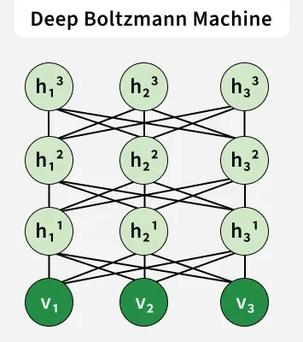
- Units are connected across layers but not within a layer, allowing the network to learn intricate feature relationships.
- Training typically involves layer-wise pretraining followed by fine-tuning.
- Common training algorithms include Contrastive Divergence (CD), Gibbs Sampling and Stochastic Gradient Descent (SGD).
- DBMs are suitable for generative modeling, unsupervised feature learning and handling high-dimensional complex data.
DBM Architecture
- Top layer is the visible layer representing input data.
- Multiple hidden layers allow hierarchical feature extraction.
- Connections exist between adjacent layers but not within a layer and all inter-layer connections are undirected.
- This structure enables the network to model complex, high-dimensional data.
How Deep Boltzmann Machines Work:
- Pre-training: Train each layer independently to learn feature representations and approximate the data distribution.
- Gibbs Sampling: Iteratively update the states of visible and hidden units using their joint probabilities to model the data accurately.
- Weight Updates: Adjust weights to minimize the energy function and maximize the probability of observed data.
- Fine-tuning: Refine the network using generative or discriminative training to improve performance on specific tasks.
- Iteration: Repeat sampling and weight updates until the DBM effectively captures complex data patterns.
Advantages
- Can learn hierarchical feature representations from raw data automatically.
- All inter-layer connections being undirected allow capturing complex dependencies.
- Suitable for generative tasks, such as image or data generation.
- Can be used for unsupervised learning and as a building block in deep architectures.
Limitations
- Training is computationally intensive due to multiple layers and undirected connections.
- Requires layer-wise pretraining and fine-tuning, which can be time-consuming.
- Sampling methods like Gibbs Sampling can be slow and require careful tuning.
- Not ideal for extremely large datasets without efficient approximation techniques.

🔷 8. Why RBM Is Less Used Today
Because modern methods replaced it:
- Autoencoders
- Variational Autoencoders
- GANs
- Transformers
But RBM is still important for:
👉 Understanding deep generative models
👉 Historical development of deep learning

Summary
Restricted Boltzmann Machine:
- Two-layer stochastic neural network
- Unsupervised learning
- Visible & hidden units
- No intra-layer connections
- Learns probability distribution
- Energy-based model
Boltzmann Machine vs Neural Network:
- RBM → generative, probabilistic
- Neural Network → predictive, deterministic

